Overview  Country: United States  Industry: Environmental Manufacturing  Customer Profile  Headquartered in Columbus, Ohio, Liebert North America is a recognized worldwide manufacturer of power protection and environmental controls equipment.  Business Situation  As it became more global, Liebert needed to improve project management to better plan, communicate, track, and report the status of projects across the organization.  Solution  Liebert chose to deploy the Microsoft® Office Enterprise Project Management Solution, which will facilitate the company’s enterprise project management strategy across the globe.  Benefits  - Improved tracking of resource time and allocation  - Facilitates collaborative work, regardless of location  - Helps bring new products to market faster |  |  | “Liebert anticipates great gains with the deployment of the Microsoft Office Enterprise Project Management Solution. With a mixture of the right processes and tools, Liebert is targeting a reduction in both development cost and time-to-market.”  Russ Shetler, Director of Engineering–Global Development, Liebert North America
 |  |  | As it looked to offshore development to help maintain its competitive edge, Liebert North America sought a way to manage its growing global human resources. At the same time, Liebert’s U.S. engineers found themselves with unfamiliar project management responsibilities, and the company realized that it needed to find an effective project management tool. Working with partner Pcubed, Liebert selected the Microsoft Office Enterprise Project Management (EPM) Solution to provide the company accurate, consistent visibility into its projects for better decision making. The solution will also save whole days of administrative time by automatically generating reports, freeing the company from its current time-consuming manual reporting processes. The EPM Solution will help Liebert truly understand how its projects are progressing and supporting its business.
 |  |  | 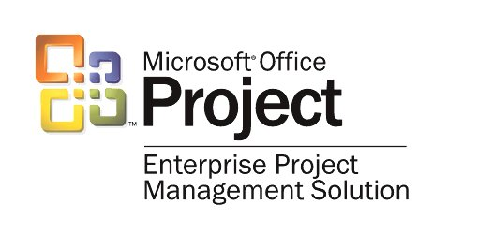

Situation
Businesses today are seeking out new ways to gain efficiency and trim costs. This is no less true of Liebert North America, a company that the world’s government bodies, telecommunications companies, hospitals, and technology leaders rely on to help protect their vital systems. Like many corporations, Liebert looked to reduce costs by distributing some of its workload overseas. Offshore product development and engineering allowed Liebert to take advantage of worldwide expertise and lower pay scales, but the move also presented some challenges.

One of the most difficult aspects of this transition was project management. Liebert was accustomed to conducting its product development in a single location. “All of a sudden, we had to find a way to work collaboratively with people all over the world, from Italy and India to China and the United States,” explains Russ Shetler, Liebert Director of Engineering–Global Development. “It’s hard enough to keep a team moving in the right direction when everyone’s in the same time zone, but working jointly across continental boundaries presented its own challenges.”
“With the corporate emphasis on global development, project management is more of a need than a luxury. We want to estimate, track, and analyze all aspects of new projects in an effort to reduce design-cycle time.”
Robert Howard, Development Scientist, Liebert North America

For instance, the prime project management method for Liebert’s Power Engineering group required plenty of manual steps. The approximately 70 power engineers tracked their various projects on paper and gave those reports to their department secretary for manual entry into a Microsoft® Excel spreadsheet. The completed spreadsheet was then distributed to concerned parties in e-mail. This whole process, which took approximately three work days, had to be repeated every month, representing a significant time investment.

The Power Engineering group needed a system that would not only make it easier and less time-consuming to track work and project hours, but also provide the team better overall visibility into project information. In addition to resource allocation reports, the team needed a way to track the amount of time it spent on non-project-specific activities, such as support, training, and paid time off. Having a single source of accurate information would help the company establish a consistent way to control and track its many engineering projects. “With the corporate emphasis on global development, project management is more of a need than a luxury,” says Robert Howard, Liebert Development Scientist. “We want to estimate, track, and analyze all aspects of new projects in an effort to reduce design-cycle time.”

The move toward offshore design and development caused many of Liebert’s U.S. engineers to take on project management duties within the company, yet most of them had little or no project management experience. Decision makers recognized that these employees needed the right project management tools and training in order to achieve success overseas.

Liebert’s executive management set the corporate objective of improving project management companywide. Liebert follows the Capability Maturity Model for Software (CMM), which is a model for judging the maturity of an organization’s software processes and for identifying the key practices that are required to increase the maturity of those processes. Management wanted to move from the “Initial” maturity level, which is characterized by ad hoc processes, to the “Repeatable” level. This evolution required the establishment of basic project management processes for tracking costs, schedules, and functionality. Liebert set out to find a tool that would help the company reach this important next level.

Solution
The Power Engineering group looked to its internal counterparts in Liebert’s Monitoring group to see what this group was accomplishing using Microsoft Project 2000 as a stand-alone product. Project provided the Monitoring group with regular reports that alerted management as to whether projects were on track and helped managers understand reasons for slippage. The program also showed the impact of various changes to project requirements and resources, as well as provided traceability and a consistent method for tracking and reporting all projects.
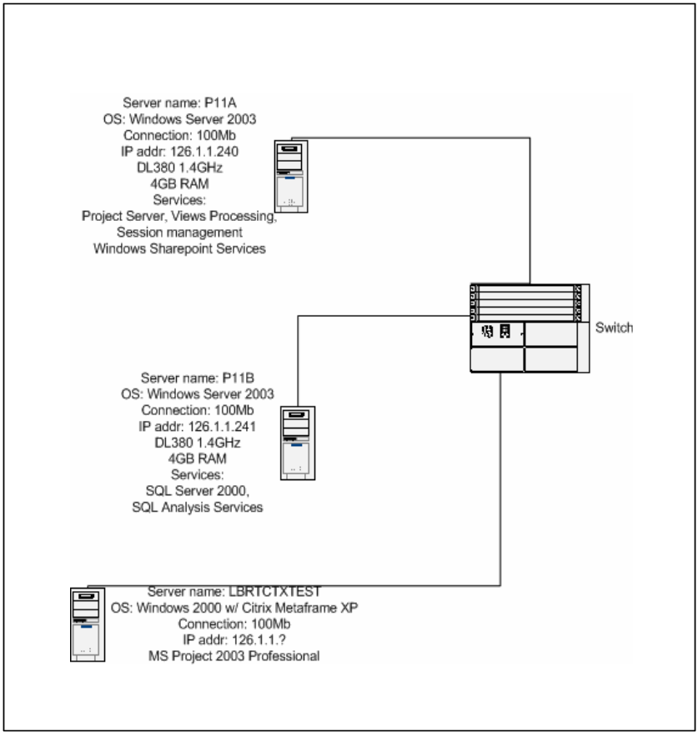
The Power Engineering group chose to build upon this initial success. Both the Power Engineering and Monitoring groups decided to design and deploy the Microsoft Office Enterprise Project Management (EPM) Solution, which provides a single repository for project information, including project schedules, issues, risks, and documents. The EPM Solution, based on Microsoft Windows® 2000 and Microsoft Windows Server™ 2003, will offer project managers, engineers, product managers, and executives real-time access to project information to improve their forecasting and decision making. The solution will not only increase the accuracy of Liebert’s metrics, including resource allocation and project milestone achievement, but also reduce the effort necessary to gather such metrics.

Liebert is currently working with Microsoft Certified Partner Pcubed to review the EPM Solution. In regard to working with a partner, Shetler says, “We definitely benefit from Pcubed’s personal interaction. Interviewing key people in the organization was very helpful in determining the scope of the pilot. It kept us from attempting to do more than we were physically capable of at the time.”
Figure 1. Current Liebert network diagram

Liebert’s proof of concept has been completed, and the pilot, which focuses on time tracking and resource allocation, is nearing its end. Implementation will begin soon to extend the project to the rest of the organization. The initial implementation will follow the pattern of the pilot, deploying time-tracking and resource allocation capabilities first, because those are the two areas that Liebert felt would have the greatest impact on its bottom line. According to Tommy Fu, Pcubed Account Executive, the pilot provides Liebert with the tools needed to determine how quickly the company can advance within the CMM. “Starting with time tracking gives Liebert a quick business win,” says Fu. “Just by having some simple reports in place, the teams will get fast snapshots of where things stand on each project, without the days it would take to manually pull together reports.”

The pilot affects approximately 100 employees who are currently working on six projects across the two engineering groups. These projects revolve around the development of next-generation power protection and monitoring systems that will be marketed worldwide. In conjunction with the pilot, Liebert is providing general project management training for those employees who require it. In addition, the company needs to define and document the policies and processes for using the new system. “To have true organizational impact, we need to focus not just on a tool, but also on training and business processes to make our people successful,” states Shetler.
“Just by having some simple reports in place, the teams will get fast snapshots of where things stand on each project, without the days it would take to manually pull together reports.”
Tommy Fu, Account Executive, Pcubed

Shetler continues, “With global engineering as our major focus, it is a natural fit for Liebert to deploy the Microsoft Office Enterprise Project Management Solution to facilitate our strategy around the world.” Liebert’s research and development projects will benefit from improved reporting, reduced planning effort, standardization, and project management process compliance. Unlike the current system of using disparate combinations of Microsoft Excel, Word, and Access, the EPM Solution gives Liebert an end-to-end solution for project planning, tracking, collaboration, and reporting.

Benefits
With the new time-tracking and resource-allocation capabilities alone, Liebert anticipates a productivity gain of 5 percent. The EPM Solution encourages widespread participation in the process improvement effort by all stakeholders, which will help the company more accurately assess its projects at the task level, including evaluating the projects’ progress and resource utilization, as well as establishing repeatable processes across various corporate projects and initiatives. This increased accuracy will have a direct impact on Liebert’s tax filings; the company receives tax breaks on its investments in research and development, and the EPM Solution will allow Liebert to quantify and record these investments more precisely.

Project Intelligence
Liebert will also be able to monitor its budget more closely. Knowing the true time and expense that it takes to complete a particular project means more informed estimates for future projects. “As we work with fewer resources, we need better efficiency, and to get it, we need to have a better view of our past and more control over our present,” states Shetler.

The EPM Solution will provide Liebert’s project managers and executives the metrics that they need at any given moment to make sound business decisions regarding their top-priority initiatives. For example, the metric calculator provides current information regarding the percentages of code inspected, the time that individuals or departments spent on scheduled tasks, the number of bugs found, and the time that it took to fix them. The EPM Solution also provides automatic re-estimation of project completion dates based on changes in resource allocation or new issues as they arise. As a result, project managers always have up-to-date information to make projections and answer the age-old question, “When will this project be finished?”

Collaboration Across the Globe
The EPM Solution will help Liebert’s project managers maintain relationships with employees both near and far. Visibility into the status of each project will be a tremendous benefit to project managers, especially those who are new to their project management roles. “Having a Web-based tool like the Microsoft Office Enterprise Project Management Solution really breaks down the time barriers for communication,” comments Howard. “We are implementing a true enterprise solution that will help us extend our reach with a standardized tool and processes for all projects.”

Building on a Successful Solution
Although the pilot is initially being deployed to a few engineering groups, Liebert executives see the potential for both project and process management improvements throughout the company. For instance, Liebert’s Marketing, Human Resources, and Network Services departments have already expressed interest in capitalizing on the success of the EPM Solution. “We expect to see all of Liebert using the Microsoft Office Enterprise Project Management Solution in the next year or two for time-tracking purposes,” says Shetler.

The company also plans to extend its project management capabilities beyond time tracking and resource allocation. “We need to see the Microsoft Office Project Enterprise Project Management Solution used for all aspects of our project management, including estimation, risk analysis, issue tracking, and more,” says Howard. Liebert views integration with the Microsoft Office Outlook® messaging and collaboration client as a vital piece of its future project management strategy. Because Liebert’s developers are being asked to manage more tools and Outlook is such a widely used application, it makes sense for the company to integrate time-tracking components into Outlook.

“Liebert anticipates great gains with the deployment of the Microsoft Office Enterprise Project Management Solution. With a mixture of the right processes and tools, Liebert is targeting a reduction in both development cost and time-to-market. This EPM Solution is a natural fit for effectively managing our global workforce and project resources,” concludes Shetler.

Microsoft Office System
For More Information
For more information about Microsoft products and services, call the Microsoft Sales Information Center at (800) 426-9400. In Canada, call the Microsoft Canada Information Centre at (877) 568-2495. Customers who are deaf or hard-of-hearing can reach Microsoft text telephone (TTY/TDD) services at (800) 892-5234 in the United States or (905) 568-9641 in Canada. Outside the 50 United States and Canada, please contact your local Microsoft subsidiary. To access information using the World Wide Web, go to: http://www.microsoft.com/

For more information about Pcubed products and services, call (734) 741-7770 or visit the Web site at: http://www.pcubed.com/

For more information about Liebert North America products and services, call (614) 888-0246 or visit the Web site at: http://www.liebert.com/

© 2003 Microsoft Corporation. All rights reserved. This case study is for informational purposes only. MICROSOFT MAKES NO WARRANTIES, EXPRESS OR IMPLIED, IN THIS SUMMARY. Microsoft, Microsoft, the Office logo, Outlook, SharePoint, Windows, Windows Server, and Windows Server System are either registered trademarks or trademarks of Microsoft Corporation in the United States and/or other countries. The names of actual companies and products mentioned herein may be the trademarks of their respective owners.

Document published October 2003

Software and Services  - Products  - Microsoft Office Outlook 2003  - Microsoft Office Project Professional 2003  - Microsoft Office Project Web Access  - Microsoft Office Project Server 2003  - Microsoft Office Project Standard 2003 | - Microsoft SQL Server 2000 Enterprise  - Microsoft Windows 2000 Server  - Microsoft Windows Server 2003  Hardware  - HP ProLiant DL380

Microsoft® Office is the business world's chosen environment for information work that provides the software, servers, and services that help you succeed by transforming information into impact. For more information about Microsoft Office System, go to:
http://www.microsoft.com/‌office/

